Geoffrey Kroll
ANTH 2030
Alan Griffiths
October 5, 2016
Petroglyphs National Monument
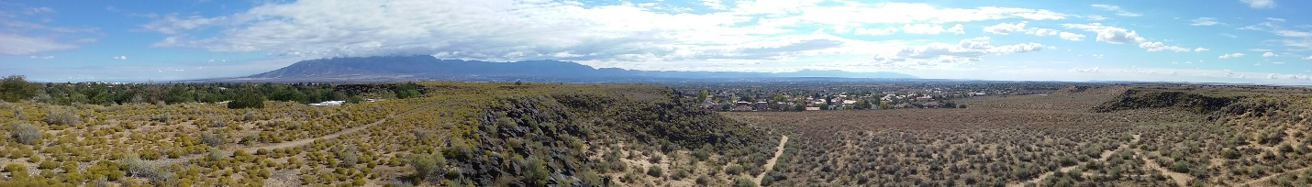
The Petroglyphs national monument is just west of Albuquerque New Mexico and raises up along the mesa for about 17 miles. (www.newmexico.org) within the national monument are three volcanos “known locally as the Albuquerque Volcanoes or the Three Sisters.” (www.nps.gov) These now extinct volcanos erupted 150,000 years ago and created the landscape of black stone and valleys that these petroglyphs now reside in.
I chose to research and present this archeological site because I got to spend a lot of time around it. I also spent some time among the ancestors of the people who left behind the petroglyphs. This site contains countless historical treasures and petroglyphs. For many years researchers, archeologists, and various New Mexico organizations have strived to develop and protect the land the petroglyphs are on. With the countless stories left behind by the ancient pueblo people and early Spanish settles the Petroglyphs National Monument is a site worth preserving and continued research.
The site has been surveyed in a variety of ways and at many different times. In 1960 “researchers also played an important role in the creation of the monument… led by Colonel Jim Bain.” In the Piedras Marcadas Canyon they discovered and recorded many Petroglyphs. (www.nps.gov) After the initial discovery of the petroglyphs over 15000 more petroglyphs have been discovered and mapped out. The monument has a variety of areas that are made available to the public where you can walk around and experience the history of the petroglyphs for yourself.
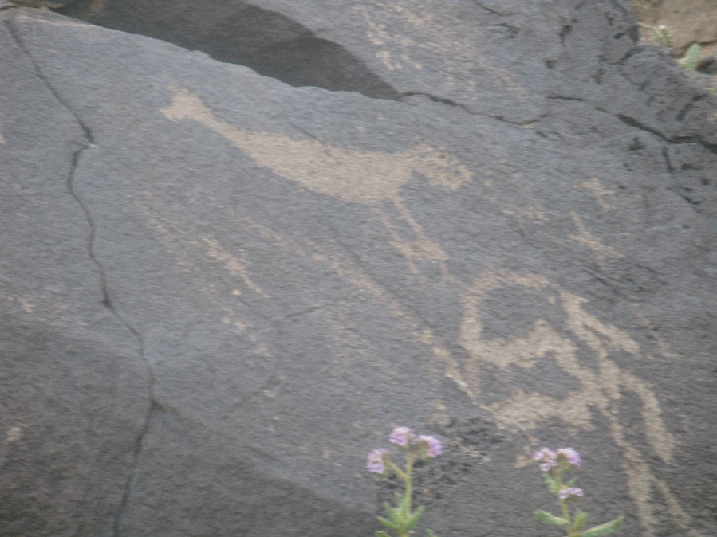
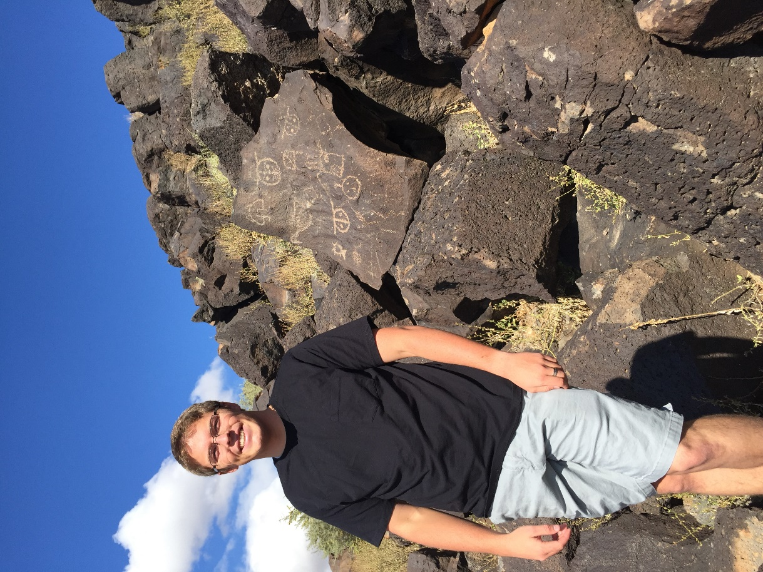

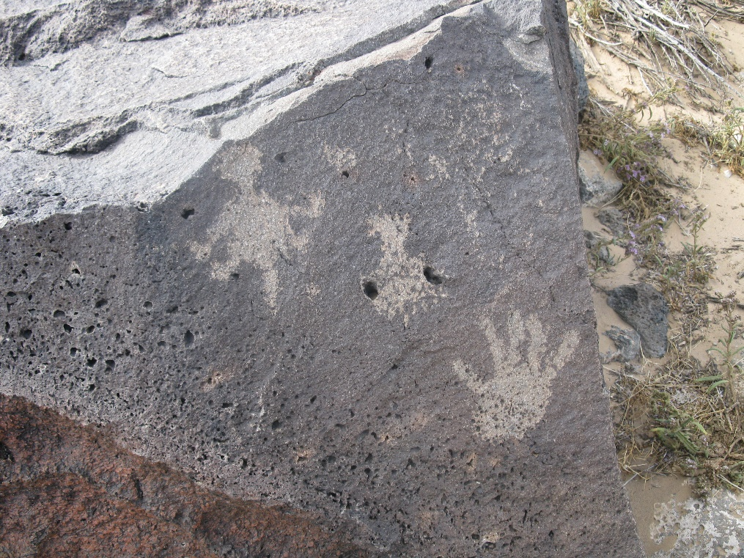

More modern day excavations take place on a smaller scale mostly with students from the local college. Frequently recruited are Central New Mexico Community College (CNM) students. In 2014 “Anthropology instructor Susan Ruth was asked… to recruit students to survey a portion of the canyon to determine if any artifacts were removed or churned up during heavy rains”. (www.cnm.edu) The main tool that was used during the excavation was a GPS. It was used “to record coordinates of any artifacts they found.” (www.cnm.edu) The group was surprised by the number of artifacts that were recorded. Grind Stones, fire cracked rocks, pottery and evidence of short term housing were found in the excavation.
In 2015 CNM got together with the archeologist of the monument and held another excavation. “’(Petroglyph National Monument) is putting in some new trails and wants to make sure they are not disturbing an archeological site.’” (www.cnm.edu) There was a significant find done by one student during the survey. “Rick Patrick, discovered a 10,000 year old spearhead, called a midland point.” (www.cnm.edu) Most of the artifacts found were left close to their original spots but due to the age of the midland point it was kept for research.
The general purpose for the two excavations was to preserve the historical value of the land. The mapping of the artifacts by GPS allowed the archeologist to track the artifacts for latter finds and keep them in their historical spot. The Midland point was significant evidence that 10,000 year ago hunters came through that spot and hunted mammoth. This could provide further reason to have more excavations in that area of the National Monument

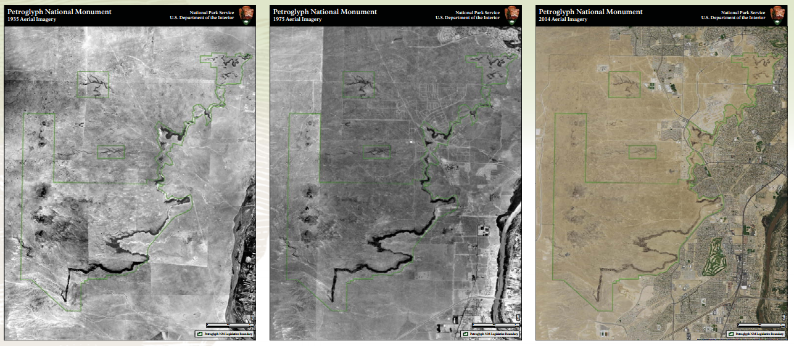
Here is a map provided by the National Parks Service showing the area over time.

2014
1935
1975

Works Cited
United States. National Park Service. "NPS.gov Homepage (U.S. National Park Service)." National Parks Service. U.S. Department of the Interior, n.d. Web. 06 Oct. 2016.
"Petroglyph National Monument." New Mexico True. N.p., n.d. Web. 06 Oct. 2016.
"Central New Mexico Community College." Central New Mexico Community College. N.p., n.d. Web. 06 Oct. 2016.

