Pipeline Project: Minimizing Cost
Report file by Geoffrey Kroll
Math 1210 – Calc. 1
April 2017

Scenario:
A company wants to drill for natural gas in vernal Utah and they need the cheapest way of laying pipes from the gas wells to their factory. The owner of the company has commissioned me to determine the cost of various situation and the cheapest way to lay the pipes. Below is an image of the layout for this scenario.


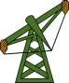
BLM Ground
8 mile

BLM Ground
16 miles
Private Ground
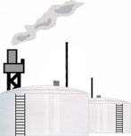

40 miles - BLM Ground

Situation A
Summary: Involves running the pipe strictly on BLM land. Two scenarios will be considered.
Situation A i:
Summary: This scenario involves running the pipeline West of the wells. Then South, and East to the refinery. The pipe costs $480,000 per mile to be laid and it will travel 64 miles across accruing no additional cost from right of way or environmental fees.
Diagram:
BLM Ground
8 mile

BLM Ground
16 miles
Private Ground

40 miles - BLM Ground

Math:
-Miles=m=8+16+40 m=64
-Cost=C(m)=480,000*(m) C(64)=$30,720,000

Situation A ii:
Summary: This Scenario involves running the pipe East through a mountain then south to the refinery. The cost of laying pipe is $480,000 per mile. With a one-time fee for drilling through the mountain at $4,500,000. There will also need to be an environmental impact study at cost of $600,000. Doing this will delay the project 8 months costing $100,000 per month. There will be no right of way fees charged. The total distance the pipe will travel is 48 miles.
Diagram:
BLM Ground
8 mile

BLM Ground
16 miles
Private Ground

40 miles - BLM Ground

Math:
-Miles=m=(40-8)+16 m=48
-Cost=C(m)=480000*(m)+4500000+600000+100000*(8) C(48)=$28,940,000

Situation B
Summary: This situation involves two scenarios of running the pipe through private land and BLM land.
Situation B i:
Summary: This scenario involves traveling the shortest distance between the wells and the refinery across private land. The pipe will cost $480,000 per mile to lay with an additional right of way fee at $360,000 per mile. There will be no additional cost for environmental reasons. The total distance of the pipe will be 35.7771 miles
Diagram:
BLM Ground
8 mile

Private Ground
BLM Ground
16 miles
35.7771 Miles
16 Miles
32 Miles
40 miles - BLM Ground

Math:
-Miles=m=16²+32²=m² m=35.7771 Miles
-Cost=C(m)=480000*(m)+360000*(m) C(35.7771)=$30,052,753.61

Situation B ii:
Summary: This Scenario involves running the pipe directly South of the wells across the private land then directly East across BLM land to the refinery. The cost of laying the pipe is $480,000 per mile. Running the pipe across private land will inflict right of way fees which will add an additional $360,000 per mile of private land. The total distance the pipe will be laid is 48 miles.
Diagram:
BLM Ground
8 mile

Private Ground
BLM Ground
16 miles

40 miles - BLM Ground

Math:
-Miles=m=16+(40-8) m=48 Miles
-Cost=C(m)=480,000*(m)+360000*(16) C(48)=$28,800,000

Cost Summary
Least expensive Scenario: Situation B ii at $28,800,000
Most expensive Scenario: Situation A i at $30,720,000

Situation C
Summary: This situation involves only one scenario. Traveling at an angle from the wells South through private land to BLM land then west to the refinery. This will find the lowest cost for building the pipe without any delays. The pipe will cost $480,000 per mile plus an additional cost of $360,000 per mile of private land for the right of way fee.
Diagram:
BLM Ground
8 mile

BLM Ground
16 miles
y
Private Ground
32-x
x
40 miles - BLM Ground

Math:
-Finding where x will bring the minimum value
y²=16²+x² y=$\sqrt{256}+\sqrt{x}$²
C(x)=480000*(32-x)+840000*y C(x)=480000*(32-x)+840000*(256+x²)^{1/2}
C(x)=15360000-480000x+840000*(256+x²)^{1/2}
C’(x)=420000*(256+x²)^{-1/2}*(2x)-480000 C’(x)=840000x*(256+x²)^{-1/2}-480000=0
480000=$\frac{840000x}{\sqrt{256}+\sqrt{x^{2}}}$ $\sqrt{256}+\sqrt{x^{2}}=\frac{840000x}{480000}$ $\sqrt{256}+\sqrt{x^{2}}$=$\left(\frac{840000x}{480000}\right)$
${\left(\sqrt{256}+\sqrt{x^{2}}=\frac{7}{4}x\right)}^{2}$ $256+x^{2}=\frac{49}{16}x^{2}$ 4096+16x²=49x²
4096=33x² x²=$\frac{4096}{33}$ x=$\frac{64}{\sqrt{33}}$

-Finding length of pipe running across private land
y=$\sqrt{256}+{√\left(\frac{64}{\sqrt{33}}\right)}^{2}$ y=19.4967 Miles
-Finding how far from the refinery the pipe will start to run on BLM land
D=32$-\frac{64}{\sqrt{33}}$ D=20.859 Miles
-The angle at which the pipe leaves the wells
$θ=\tan^{-1}\left(\frac{4}{\sqrt{33}}\right)$ $θ=34.8499°$
-Find the minimum cost of laying pipe from natural gas well to the refinery
Cost=C=840000*(19.4967)+480000*(20.859) C=$26,389,548

Final Verdict
The best way to minimize time and money used on this pipe laying project would be to follow the layout of situation C. It comes to a cost of $26,389,548 and the total distance the pipe will travel is 40.36 Miles.
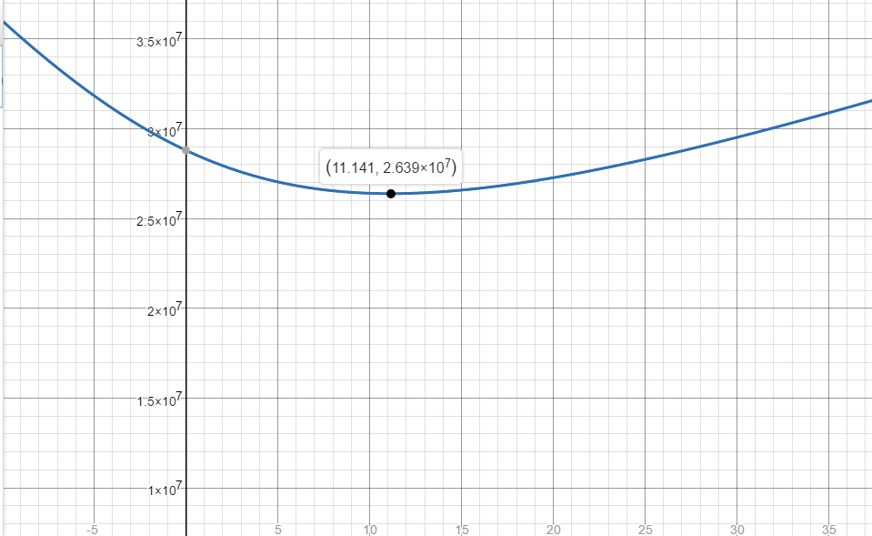
C: Graph

C(x)=480000*(32-x)+840000*(256+x²)^{1/2}

Reflection:
Calculus this year has been the most fun I have had with math for the longest time. It is one of the most interesting areas of math. I feel like not only has it made me look at math a different way but its allowed me to expand my mind in a variety of other areas outside of math. Calculus helps you to look at a situation not just from a new perspective but from a variety of perspectives. It’s not just learning some new functions it’s a new way of thinking. Calculus is a wonderfully useful tool. Not only can it make finding maximums and minimums easier but a variety of other options become available with the various tools from calculus. I’ll admit that calculus isn’t easy nor is it impossible to learn. It does take work and practice. I’m excited to use calculus more in my future especially in my future career as an engineer.

